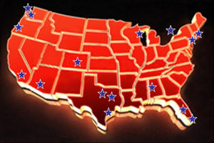
USA SWING NET EVENT CALENDAR

Enjoy this 10-page chronological “thumbnail” of the dance events and cruises on The USA Swing Dance Network. Download it for year-round reference to plan trips.

The USA Swing Net is comprised of events that feature ocean venues, downtown venues, airport venues, and theme park venues. Plus, Swing Dance Cruises!

Each event on the USA Swing Net has a different flavor, size and theme. Some offer a wide selection of Workshops. Others offer Pro-Am divisions and various other styles of dance in addition to West Coast Swing. Still others have elaborate Entertainment Shows as part of their presentation. There’s lots of variety.

In addition to the event itself, many Host Cities are also popular tourist destinations so be sure to arrive early, stay late and enjoy a mini-vacation.

Below are brief profiles of each USA Swing Net member event. Just click www.usaswingnet.com to visit each of our Swing convention websites for important ticket, hotel, travel, competition, and workshop information.

Now join us on a "chronological tour" across America to explore the many exciting competition events on The USA Swing Dance Network !!!

Dallas D.A.N.C.E. • Phoenix 4th of July Convention
Seattle’s Easter Swing • Summer Hummer • Swing Niagara
Swingin’ into Spring • DFW Pro Am Jam • Miami Dance Magic
High Desert Dance Classic • Swingtime in the Rockies • Dance ‘n Play
Florida Swing Vacation • Swing Dance America • Derby City Swing
The Toronto Open Swing & Hustle Dance Championships
San Francisco Dance Sensation • Sea To Sky Seattle

JANUARY


Derby City Swing (January 30 – February 2, 2014)

City: Louisville, Kentucky
Inaugural Year: 2014
Hosts: Brian Barkauskas & Louis St.George
Estimated Attendance: 350
Divisions: Swing
Workshops: 17
Dance Floor: 4,000 sq feet (2 Ballrooms)
Special Features: Thursday Party, FREE Beginner Track, Pool Party
Local Tourist Attractions: Churchill Downs (home of the Kentucky Derby), KFC world headquarters, Louisville Slugger Museum

 
The High Desert Dance Classic (March 14-16, 2014)

City: Lancaster, CA
Inaugural Year: 2005
Competition Tours Offered: WSDC
Host: Lisa Sandoval
Estimated Attendance: 1,800
Divisions: Swing, Hustle, Salsa, Latin, Ballroom
Workshops: 33
Dance Floor: 3 Ballrooms
Special Features: Youth Division, 3-Dance Divisions, Dancing Feet
Local Tourist Attractions: Museum, Art Gallery, Woodland Preserve

APRIL

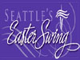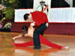
Seattle's Easter Swing (April 17-20, 2014)

City: Seattle, Washington
Inaugural Year: 1992
Competition Tours Offered: WSDC, AANCE
Host: Seattle WC Swing Dance Club
Estimated Attendance: 600
Divisions: Swing
Workshops: 32
Dance Floor: 3,600 sq. ft. (2)
Special Features: Hospitality Suite, Sunday Post Party
Local Tourist Attractions: Seattle Space Needle, Pike Street Fish Market, Art Museum, Microsoft

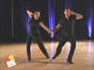
San Francisco Dance Sensation (April, 2014)

City: Oakland, California
Inaugural Year: 2013
Competition Tours Offered: WSDC
Host: Chuck Brown
Estimated Attendance: 500
Divisions: Swing,
Workshops: 46
Dance Floor: 3,200 sq. ft.
Special Features: The “SHOW”
Local Tourist Attractions: Golden Gate Bridge, Fisherman’s Wharf

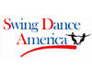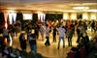
Swing Dance America (April 24-28, 2014)

City: Lake Geneva, Wisconsin
Inaugural Year: 2007
Competition Tours Offered: WSDC, AANCE, MASTERS
Host: Glen Miller
Estimated Attendance: 500
Divisions: Swing, Hustle
Workshops: 31
Dance Floor: 3,200 sq. ft.
Special Features: Ice Cream Social, Midnight Buffet, Golf Tournament
Local Tourist Attractions: Wisconsin Dells, Horse Back Riding

MAY

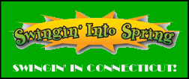 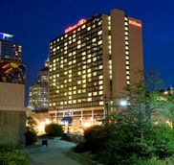
Swingin' Into Spring (May 1-4, 2014)

City: Hartford, Connecticut
Inaugural Year: 2007
Competition Tours Offered: WSDC
Host: Ken Mercik
Estimated Attendance: 400
Divisions: 6
Workshops: 24
Dance Floor: 4,400 sq. ft. (2)
Special Features: No Evening Comps, Thursday Party, sports water bottle for all Weekend Pass holders
Local Tourist Attractions: Mark Twain House & Museum, Art Museum, Basketball Hall of Fame

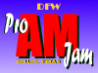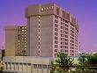
DFW Pro Am Jam (May 22-25, 2014)
City: Dallas, Texas
Inaugural Year: 2010
Competition Tours Offered: WSDC, Golden Ticket
Host: Lori Hayner & Glenn Boren
Estimated Attendance: 500
Divisions: 16
Workshops: 9
Dance Floor: 6,000 sq. ft.
Special Features: Saturday and Sunday Midnight Buffets, “Dancin’ n the JAM”, Costume Party
Local Tourist Attractions: John F. Kennedy Memorial, Dallas Cowboys Stadium

JUNE

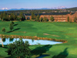
Dance ‘n Play (June 12-15, 2014)

City: Redmond, Oregon
Inaugural Year: 2012
Competition Tours Offered: N/A
Host: Cheryl Lyons
Estimated Attendance: 300
Divisions: Swing, Variety
Workshops: 28
Dance Floor: 3,200 sq. ft.
Special Features: Horseback Riding, Canoeing, White Water Rafting, Mountain Climbing, Golf
Local Tourist Attractions: Eagle Crest Resort

JULY
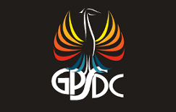 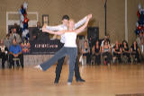
Phoenix 4th of July Convention (July 2-6, 2014)

City: Phoenix, Arizona
Inaugural Year: 1982
Competition Tours Offered: WSDC, AANCE
Host: Greater Phoenix Swing Dance Club
Estimated Attendance: 800
Divisions: 6
Workshops: 12
Dance Floor: 4,000 sq. ft.
Special Features: Wednesday & Thursday Kickoff Parties, Pool Party, Friday &
Saturday Midnight Buffets, Hospitality Suite, Entertainment Show, Golf Tournament.
Local Tourist Attractions: Camelback Mountain, Pueblo Indian sites

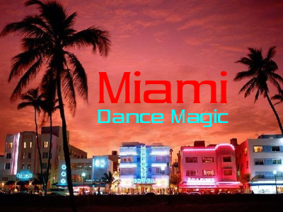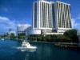
Miami Dance Magic (July 17-20, 2014)

City: Miami, Florida
Inaugural Year: 2008
Competition Tours Offered: WSDC, AANCE, IHDA
Host: Bruce & Beth Perrotta
Estimated Attendance: 600
Divisions: 23
Workshops: 25
Dance Floor: 5,000 sq. ft. (3)
Special Features: Entertainment Show
Local Tourist Attractions: South Beach, Seaquarium, Bayside Marketplace

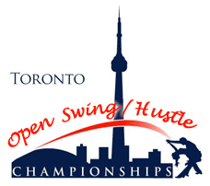 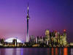
The Toronto Open Swing & Hustle Dance Championships (July 17-20, 2014)

City: Toronto, Ontario, Canada
Inaugural Year: 2008
Competition Tours Offered: WSDC
Host: Toronto Open Swing Dance Championships
Estimated Attendance: 400
Divisions: 21
Workshops: 40
Dance Floor: 3,900 sq. ft. (3)
Special Features: Saturday Night Showcase, Saturday Barbecue, Saturday Midnight Buffet
Local Tourist Attractions: CN Tower, Skydome, Niagara Falls

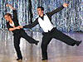
Swingtime in the Rockies (July 17-20, 2014)

City: Boulder, Colorado
Inaugural Year: 1992
Competition Tours Offered: WSDC, NASDE
Host: Rocky Mountain Swing Club
Estimated Attendance: 700
Divisions: 12
Workshops: 16
Dance Floor: 3,800 sq. ft.
Special Features: Thursday Kickoff Party, Hospitality Suite
Local Tourist Attractions: Rocky Mountains, Downtown Denver

AUGUST

 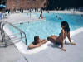
Summer Hummer (August 21-24, 2014)

City: Framingham, Massachusetts
Inaugural Year: 2003
Competition Tours Offered: WSDC, MASTERS, AANCE
Host: Bill Cameron
Estimated Attendance: 500
Divisions: 30
Workshops: 14
Dance Floor: 3,200 sq. ft.
Special Features: Friday & Saturday Midnight Buffet, Saturday Pool Party & Barbecue
Local Tourist Attractions: Downtown Boston

SEPTEMBER

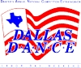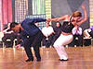
Dallas D.A.N.C.E. (August 28-31, 2014)

City: Dallas, Texas
Inaugural Year: 1987
Competition Tours Offered: WSDC, NASDE, AANCE, MASTERS
Host: Dallas Push Club
Estimated Attendance: 1,500
Divisions: 16
Workshops: 8
Dance Floor: 5,000 sq. ft.
Special Features: Entertainment Show, Backdrop, Video Screens, Open Seating
Local Tourist Attractions: John F. Kennedy Book Depository Memorial, Dallas Cowboys Stadium

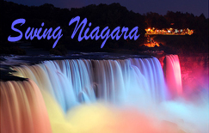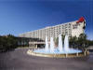
Swing Niagara (September, 2014)

City: Buffalo, New York
Inaugural Year: 2004
Competition Tours Offered: WSDC, AANCE
Host: Maria Cirino
Estimated Attendance: 400
Divisions: 24
Workshops: 48
Dance Floor: 3,200 sq. ft.
Special Features: Thursday Bus to Niagara Falls, Earlybird Dance, Entertainment Show
Local Tourist Attractions: Niagara Falls, Niagara on the Lake
DECEMBER

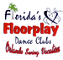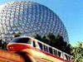
Florida Swing Vacation (December 27, 2013 – January 1, 2014)

City: Orlando, Florida
Inaugural Year: 1992
Competition Tours Offered: WSDC
Host: Mark Traynor
Estimated Attendance: 600
Divisions: 5
Workshops: 12
Dance Floor: 3,200 sq. ft.
Special Features: Pool Party, Pizza Party, New Year’s Eve Party, Champagne & Party Favors
Local Tourist Attractions: Disney, Epcot, Universal, Sea World, Wet ‘n Wild, MGM Theme Parks

SWING DANCE CRUISES
The USA Swing Net also highlights member Swing Dance Cruises. Each dance cruise includes Workshops, Parties, Food, and Entertainment. For specific details about costs, dance pros, workshops, and cruise features, please click the link below:

www.usaswingnet.com/dance_cruises.htm

USA SWING NET SPONSORS
Dance Connection Store
Official Dance Shoe Sponsor of The USA Swing Dance Network!
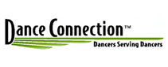

Event Express Pro
Official Electronic Registration and Wireless Scoring Sponsor for The USA Swing Dance Network


Omara Sprung Dance Floors
Official Dance Floor Sponsor of The USA Swing Dance Network
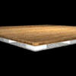

The World of Shirts
Official Apparel Sponsor of The USA Swing Dance Network!
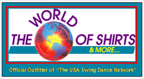

Sundancer Cruises – Dance Across the Seas
Official Dance Cruise Sponsor of The USA Swing Dance Network!
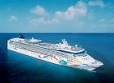

www.usaswingnet.com
