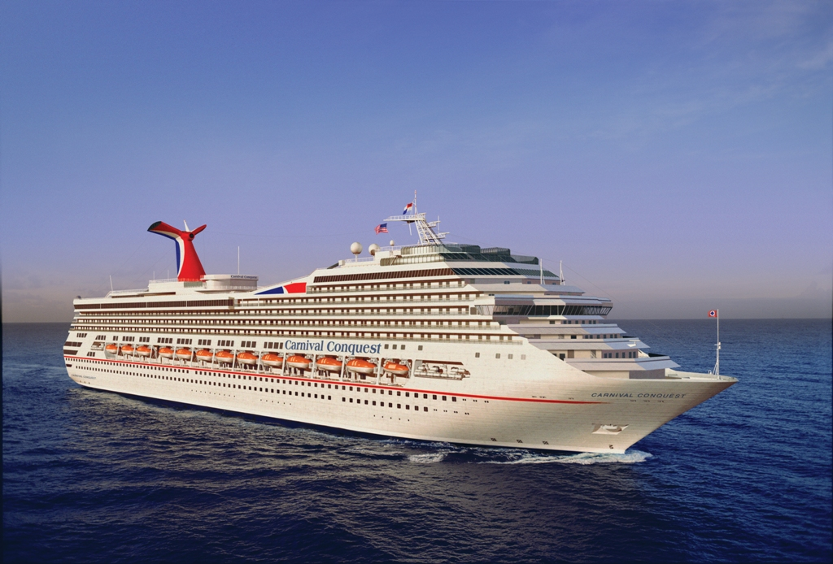
SWING DANCE CRUISE HOSTED BY: LUIS CRESPO
SWING DANCE CRUISE HOSTED BY:

PROFESSIONAL DANCE INSTRUCTOR
LUIS CRESPO
US OPEN SWING DANCE CHAMPION
Glass Dancer - Northern California
www.glassdancer.com

PROFESSIONAL DANCE INSTRUCTOR
JUNE “Sugar” RENNER
UCWDC
Chance2Dance Studio - Maryland
www.chance2dancestudio.com

EASTERN CARIBBEAN
DEPARTS FROM:
NEW ORLEANS - JAZZ!
2/5 - 2/12 2012 - 7 NIGHTS
PORTS OF CALL:
> KEY WEST, FLORIDA
> NASSAU, BAHAMAS
> FREEPORT, BAHAMAS

- BEAUTIFUL BEACHES
- SNORKELING, DIVING,
AND WATER SPORTS
- SHOPPING AND TOURING
- COUPLES, SINGLES, FAMILY
- PRE - CRUISE HOTEL/DANCE

*Excursions optional with fee

We Welcome a
Community of Diversity!

INSIDE | OCEANVIEW | BALCONY
$ 629 PP/DO | $739 PP/DO | $889 PP/DO
- Limited cabin availability in each category - BOOK NOW!
- Prices include ports/taxes/meals and all dance activities
- Cabin shares available for singles on a limited basis
- $250 deposit per person to reserve and assign cabin:
-1st deposit $50 per person due at booking (non-refundable)
-2nd deposit $200 per person due by 9/08 (refundable)
Dance Cruise Group Manager: Deb Dodd
Travel Plus RI - Coventry, RI

http://www.DanceAcrossTheSeas.com

http://www.TravelPlusRI.com

DebDoddCruises@aol.com

401 828 4376 Monday – Friday 8:00 AM - 8:00 PM

DANCE LESSONS - WC SWING, EC SWING AND HUSTLE FOR FUN!
SOCIAL DANCES, GROUP COCKTAIL PARTY AND *SHORE EXCURSIONS!
JACK&JILL SWING COMPETITION FOR CASH PRIZES!!
PROFESSIONAL DJ FOR OUR PRIVATE DANCE FUNCTIONS!

CARNIVAL CONQUEST

LET'S DANCE ACROSS THE SEAS!

